Investigating eHMI in Autonomous Vehicle - Pedestrian Scenarios
April 4th, 2025
- Introduction
Concepts and communication goals
This paper proposes two new eHMI solutions for enhancing pedestrian-automated vehicle communication in urban settings. The first system uses ground-projected stop signs, such that if an automated car meets a pedestrian stepping into the road, it will slow down 1.5 meters before the pedestrian and project a stop sign on the ground, hence effectively demonstrating the intent to yield. The second option is smart crossings with permanently flashing 'cross the street here' signals and coordinated traffic light control to provide safe crossing zones. The two designs have three core objectives, which are addressing uncertainty of right of way; developing standard communication standards; and developing pedestrian confidence through easy-to-understand visual interface. They emphasize real-time responsiveness, cross-cultural interpretability, and seamless integration into city infrastructure to support effective deployment in a range of traffic conditions.

Target scenarios and potential users
The e-HMI solutions mentioned in the paper address two important urban mobility scenarios: neighbourhood streets where pedestrians are prone to jaywalking (addressed by surface-projected parking systems) and multi-directional pedestrian flows through high-traffic intersections (controlled by smart pedestrian crossing systems). These systems are primarily designed for vulnerable road users such as children, elderly pedestrians, and mobility-impaired people who need clearer right-of-way communication, as well as automated vehicles and urban planners planning smart city infrastructures. They are particularly suitable for challenging environments, such as low-visibility environments, high-density urban areas and multicultural environments, where conventional traffic signals may not work.

The importance of visual interfaces
Visual interfaces play a key role in the interaction between automated vehicles and pedestrians. Dynamic elements such as flashing lights and animations provide clear indications of system status and alerts, outperforming static signage. In addition, these interfaces can be seamlessly integrated with smart city infrastructure to create a unified urban communications network. Their effectiveness has been demonstrated by empirical studies, including the EU interACT project, where a 30 per cent reduction in pedestrian crossing hesitation and a 40 per cent reduction in the risk of accidents in mixed traffic environments proved their vital role in ensuring safe and efficient interactions between automated vehicles and pedestrians (Lee & Domeyer, 2021).
Summary of the research article
In a human-driven vehicle, the driver conveys their intentions to pedestrians through non-verbal signals such as vehicle speed, eye gaze, and hand gestures. However, in an autonomous vehicle, pedestrians can only infer the vehicle's intentions from the vehicle itself. Through research, we investigated the role of interfaces that can explicitly communicate the intentions of autonomous vehicles to pedestrians in crosswalk scenarios, beyond vehicle movement. The interactions between vehicles and pedestrians are complex and diverse. Vehicles can communicate their intentions to pedestrians through movement patterns such as speed, acceleration, and stopping distance (Mahadevan et al., 2017). Vehicles can also provide feedback to pedestrians based on road infrastructure, such as traffic lights. The article also mentions the visual modality. It mainly utilizes visual elements such as colors, patterns, and texts that pedestrians can perceive (Mahadevan et al., 2017).

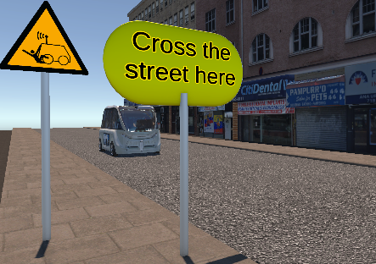
- eHMI Concept Designs
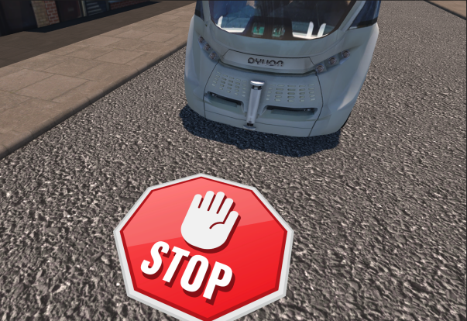
Scenario 1 screenshot Scenario 2 screenshot
project the STOP sign in front of the car the sign "Cross the street here"

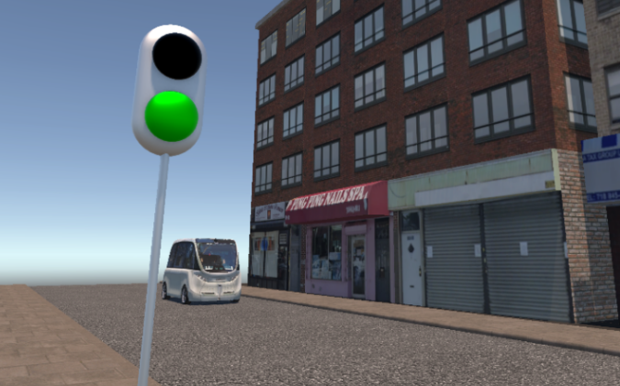
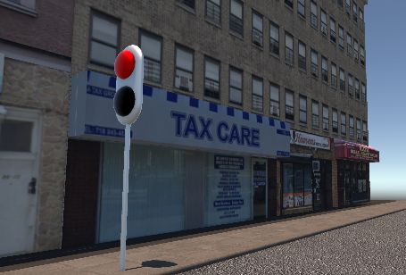
Scenario2 screenshot Scenario2 screenshot
when the light is red, the shuttle stops when the light is red, the shuttle moves

The interactive elements
In Scenario 1, distance detection is employed. The system continuously monitors the distance between pedestrians and the shuttle. When the distance reaches 1.5 meters, it will trigger the vehicle to stop. This interactive element determines the exact moment when the vehicle should halt to avoid potential collisions with pedestrians.Scenario 1 also utilizes the projection of a STOP sign. After the shuttle stops, a STOP sign is projected onto the ground. This visual cue element provides pedestrians with a clear signal for them, enhancing their understanding of the situation.
In Scenario 2, a sign that reminds pedestrians to "cross the road here" and keeps flashing to alert passers-by. When a pedestrian walks to the designated crossing position, the traffic light will change from green to red. The shuttle will stop when it recognizes the red light. When the pedestrian is in the middle of the road, the red light will remain on, and the vehicle will stay stationary. The traffic light will change from red to green until the pedestrian has successfully crossed the road, and the vehicle will resume driving after recognizing the green light.

Design conveys awareness and intent
In Scenario 1, the distance-based triggering mechanism is a fundamental safety feature. It operates by continuously evaluating the spatial relationship between pedestrians and the shuttle. The system can precisely determine when a pedestrian approaches within 1.5 meters of the shuttle. This continuous monitoring can signal the shuttle's control system that action needs to be taken, and it also subtly conveys to the pedestrians that their movements are being closely observed. As the distance decreases, pedestrians can be aware that the shuttle may react, creating a sense of mutual understanding and safety in the interaction. It lays the foundation for the vehicle's subsequent actions, clearly indicating that it is aware of the pedestrian's presence and prioritizing safety by initiating appropriate responses at the right time.
The projection of the STOP sign on the ground is a powerful visual communication element. Once the shuttle stops due to a pedestrian being within 1.5 meters, the STOP sign will be projected onto the ground. This highly visible sign serves as a clear and unambiguous indication of the shuttle's status. For pedestrians, it can immediately provide the assurance that the vehicle has stopped and intends to remain stationary, enabling them to cross the road with confidence. Therefore, the projection of the stop sign enhances the clarity of the overall situation and reinforces the vehicle's intention to ensure pedestrian safety.
In Scenario 2, to communicate awareness and intent about the constantly flashing "Cross the street here" sign. The awareness is that the constant flashing of these signs can effectively attract the attention of pedestrians, highlighting a safe and appropriate place for them to pass, and further alerting them to pay more attention. The intent is clearly stating "Cross the street here," the sign communicates to pedestrians the specific intent of where to cross the street. With such clear instructions, there is less confusion and they are encouraged to take advantage of this exact point, which is said to be equipped with security measures to make the crossing safer.
Traffic light systems communicate awareness and intent in the following ways. Traffic lights change from green to red when a pedestrian approaches a designated crossing position. This change makes vehicles aware that pedestrians intend to cross the road. As a general stop signal, the red light ensures that the vehicle recognizes the presence of pedestrians and the need to stop. When pedestrians are in the middle of the road, the continuous red light makes the vehicle realize that it must stay stopped to avoid traffic accidents. In terms of intention, when a pedestrian approaches, the traffic light changes from green to red, clearly indicating the pedestrian's intention. After the pedestrian has successfully crossed the road, the green light signals the vehicle to continue.

- User Testing & Evaluation

Objectives and methodology
This user test aims to evaluate the usability of the human-machine interaction interfaces in two scenarios of crossing the road, compare the performance of the two designs in multiple aspects such as safety and adaptability to adverse weather conditions, and collect user feedback for design improvement. Data collection is carried out by distributing the System Usability Scale (SUS), the scenario comparison table, and a customized questionnaire to 4 participants. The SUS contains 10 questions and is used to measure users' subjective feelings about the interface. The scenario comparison form covers 10 dimensions, enabling users to compare and score the two concepts in different aspects. The customized questionnaire is designed to obtain users' more in-depth opinions on specific aspects of the scenarios.

3.2 Collected results

Quantitative data
SUS score of Scenario 1: The scores of the four participants are 75 points, 75 points, 62.5 points, and 87.5 points respectively, with an average score of 75 points. This indicates that users have a relatively favorable overall evaluation of the usability of the human-machine interaction interface in Scenario 1, and the interface has been somewhat recognized by users in terms of ease of use, function integration, and other aspects. SUS score of Scenario 2: The scores of the four participants are 62.5 points, 62.5 points, 50 points, and 75 points respectively, with an average score of 62.5 points. In comparison, the score of Scenario 2 is lower than that of Scenario 1, suggesting that users' evaluation of the usability of the interface in Scenario 2 is slightly inferior.
Qualitative observations
The participants provided feedback that in Scenario 1, the brightness and position of the stop sign were appropriate, but some people thought that the sign was too bright. In Scenario 2, the flashing sign caused issues such as being too glaring and interfering with judgment for some individuals, and there is room for improvement in the matching degree of the traffic light changes. Meanwhile, the participants held different opinions regarding the sense of reassurance, the guidance for multiple people crossing the road, the interaction mode, and the selection of scenarios suitable for the elderly to cross the road.

3.3 Analysis and recommendations
3.31 System Usability Scale Results
For Scenario 1, the score of 75 points indicates that it performs well in terms of system usability. From the perspective of scenario design, when a pedestrian is 1.5 meters away from the autonomous vehicle, the shuttle bus automatically stops and projects a stop sign onto the ground. This design is highly intuitive and simple. Regarding the questions in the SUS scale such as "I thought the external Human-Machine Interface was easy to use." and "I felt very confident using the external Human-Machine Interface.", participants may have given high evaluations due to the simple and straightforward interaction logic of this scenario. In this scenario, pedestrians can easily understand it, which reduces their cognitive burden and makes them feel at ease when crossing the road, thus increasing the overall usability score.
In contrast, for Scenario 2, the average score of 62.5 points indicates that its usability is relatively weak. In Scenario 2, a sign saying "Cross the road here" and the logic of traffic light changes are designed to guide pedestrians to interact with the autonomous shuttle bus. In the feedback of the SUS scale, it scored poorly on questions such as "I found the external Human-Machine Interface unnecessarily complex" and "I needed to learn a lot of things before I could get going with this external Human-Machine Interface.". For example, the constantly flashing sign may be glaring or distracting for some pedestrians. Although the complex logic of the traffic lights changing according to the pedestrians' positions plays a certain role in ensuring safety, the excessive number of rules increases the learning cost for pedestrians, causing them to possibly feel confused when using this scenario, thus reducing the evaluation of its usability.
Overall, Concept 1 received a high SUS score due to its simple design, while the usability score of Concept 2 was affected by its complex guiding mechanism.

3.32 Comparative Analysis of Both Designs
Analyzing the data from the 10 dimensions covered in the comparison form, in terms of the safety dimension, Scenario 2, with its mechanism of controlling the vehicle's movement by coordinating the changes in traffic lights with the pedestrians' positions, is more likely to reduce the collision risk between vehicles and pedestrians compared to Scenario 1. In terms of adaptability to adverse weather conditions, the flashing signs and the traffic light system in Scenario 2 are less interfered with by weather factors. However, the stop sign projected on the ground in Scenario 1 is likely to have its visibility affected in adverse weather.
In terms of the dimension of conveying intentions during peak hours, the change of traffic lights in Scenario 2 can guide pedestrians more clearly. When it comes to handling multiple pedestrians crossing the road, the rule-based design of Scenario 2 has more advantages in maintaining the order of passage. In terms of the reaction speed to pedestrians changing lanes, the emergency stop function of Concept 1 can respond in real time. Regarding the dimension of safety and visibility at night, the flashing signs in Scenario 2 are obviously more eye-catching.
In terms of educating children on crossing the road safely, the clear guiding method in Scenario 2 is more convenient for children to understand and follow. When dealing with disorderly crowds, the automatic stop function in Scenario 1 can better restrain the behaviors of both vehicles and pedestrians. When a vehicle is approaching, to reduce pedestrians' fear, the guiding signs and the change of traffic lights in Scenario 2 can give pedestrians a greater sense of security. In the dimension of helping visually impaired people cross the road, the automatic stop function in Scenario 1 provides convenience for visually impaired people.
Overall, in these dimensions of practical applications, Scenario 2 performs more excellently in most cases, fully demonstrating its unique value in the process of implementing functions in specific scenarios.

3.33 Qualitative Observations and Feedback
Regarding the customized questions, based on the responses of the four participants: Visually, most people found the brightness of the stop sign in Scenario 1 appropriate, while one person thought it was too bright. As for the flashing sign in Scenario 2, some people felt that it was dazzling. In terms of the sense of security and preference, the majority of people believed that Scenario 1 made them feel more at ease, and its interaction mode was also more favored. When it came to the effectiveness of traffic guidance, Scenario 1 was slightly better, but both scenarios needed improvement. Regarding time and matching degree, there was room for optimization in the duration of Scenario 1 and the traffic light matching degree of Scenario 2. In terms of information interference, the flashing frequency of the sign in Scenario 2 was disturbing to some people. Regarding the applicability to special groups, both scenarios needed to be improved in terms of their adaptation to the elderly.

3.4 Comparison
When comparing these two interface concepts, Scenario 1 performs better in terms of usability and is also more favored by the participants. Its average SUS score is higher than that of Scenario 2, which means that the participants find it easier to use and more intuitive. The qualitative feedback also confirms this: most people believe that the brightness of the stop sign in Scenario 1 is appropriate and easy to notice, and the projection time of the sign is also proper. However, the flashing sign in Scenario 2 makes some people feel that it is dazzling and also interferes with the judgment of traffic information. In terms of preference, three-quarters of the participants feel more at ease with Scenario 1 when crossing the road, and two-quarters of the people prefer the interaction mode between Scenario 1 and the autonomous shuttle bus. Although Scenario 2 has advantages in practical application dimensions such as safety and adaptability to adverse weather conditions, considering the comprehensive usability and the direct feedback from the participants, Scenario 1 performs better.

- Reflections and Conclusions
There are challenges in vehicle-pedestrian communication in these two scenarios. In terms of information transmission, the parking sign in Scenario 1 has low visibility in adverse weather conditions. The flashing sign in Scenario 2 is affected by ambient light and interferes with pedestrians' judgment of other traffic information. Regarding pedestrians' understanding and adaptation, the complex logic of traffic light changes in Scenario 2 makes it difficult for some pedestrians to understand and adapt. In terms of the timeliness of system response, in Scenario 1, there may be delays in detection and response when pedestrians make sudden movements or when multiple people are crossing the road. In Scenario 2, sensor failures or data transmission delays will lead to untimely traffic light changes, affecting the vehicle's response.
If additional time were available, the prototype could be upgraded. LED indicator strips would be added to the vehicle's sides to show its perception of pedestrians via different colors and flashes. Sound effects for starting and stopping would be included to supplement the LED cues. Both would integrate with existing detection and movement algorithms. For better accessibility, sound effects could be made more descriptive for the visually impaired, and tactile elements considered for the LED area. User testing would be carried out, and the new features refined based on feedback to enhance vehicle-pedestrian communication's usability and safety.

Reference
- European Commission. (2020). Standardizing eHMIs for automated vehicles (Report No. 814495). interACT Consortium.
https://www.interact-roadautomation.eu/

- Lee, J. D., & Domeyer, N. (2021). Human factors considerations for automated vehicle-pedestrian interaction. Transportation Research Part F: Traffic Psychology and Behaviour, 78, 10-25.
https://doi.org/10.1016/j.trf.2021.02.003

- Zhang, Y., Abdel-Aty, M., Wu, Y., & Zheng, O. (2022). Pedestrian crossing behavior in automated vehicle environments. Accident Analysis & Prevention, 168, Article 106589.
https://doi.org/10.1016/j.aap.2022.106589

- Mahadevan Clamann, Miles Aubert, and Mary L Cummings. 2017. Evaluation of Vehicle-to-Pedestrian Communication Displays for Autonomous Vehicles. Technical Report.

